**MODERN DATABASE SYSTEM LAB 4**

**INDIA WEATHER ANALYTICS USING HISTORICAL DATA PART- II**

QUESTION 1:

select city ,avg(temp) as average_temp

from weather_india

group by city

order by avg(temp) desc;

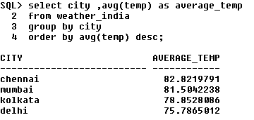

QUESTION 2:

select city, avg(temp) as average_temp_1995_to_feb_2020

from weather_india

where year > 1995 and (year <= 2020 and month = 2)

group by city

order by city;

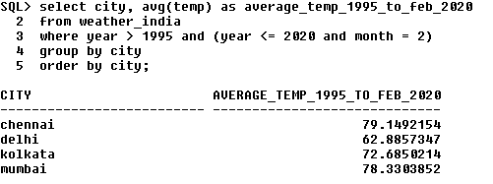

QUESTION 3:

select min(temp) as lowest_temp_in_kolkata,

max(temp) as highest_temp_in_kolkata,

avg(temp) as average_temp_in_kolkata

from weather_india

where city = 'kolkata'

and year >= 2010 and year <= 2020;

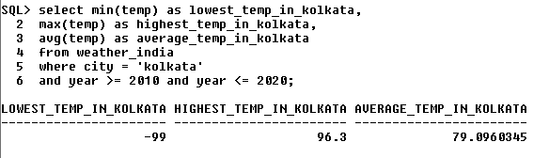

QUESTION 4:

select city, avg(temp) as avg_temp_atleast_40de_apl_19

from weather_india

where temp >= 40 and month = 4 and year = 2019

group by city;

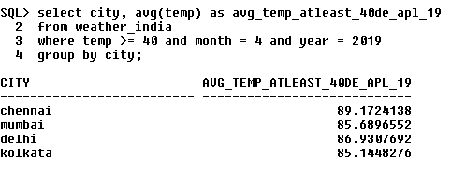

QUESTION 5:

select month, avg(temp) as avg_temp_chennai_2019

from weather_india

where city = 'chennai' and year = '2019'

group by month

order by month;

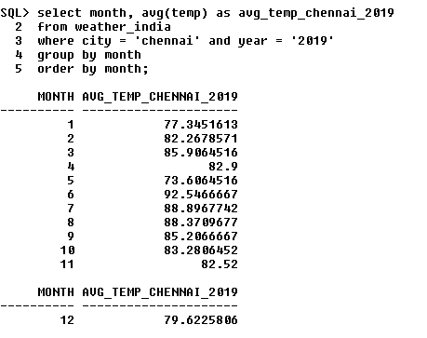

QUESTION 6:

select year, avg(temp) as avg_temp_mumbai

from weather_india

where city = 'mumbai'

group by year

order by avg(temp) desc;

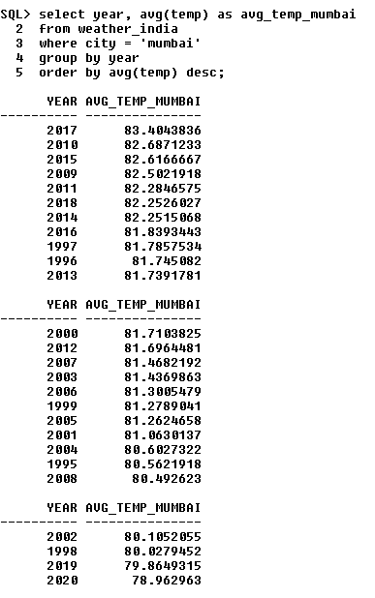

QUESTION 7:

select city, year, avg(temp)

from weather_india

where year in (2017, 2018, 2019)

group by city, year

order by city, year;

